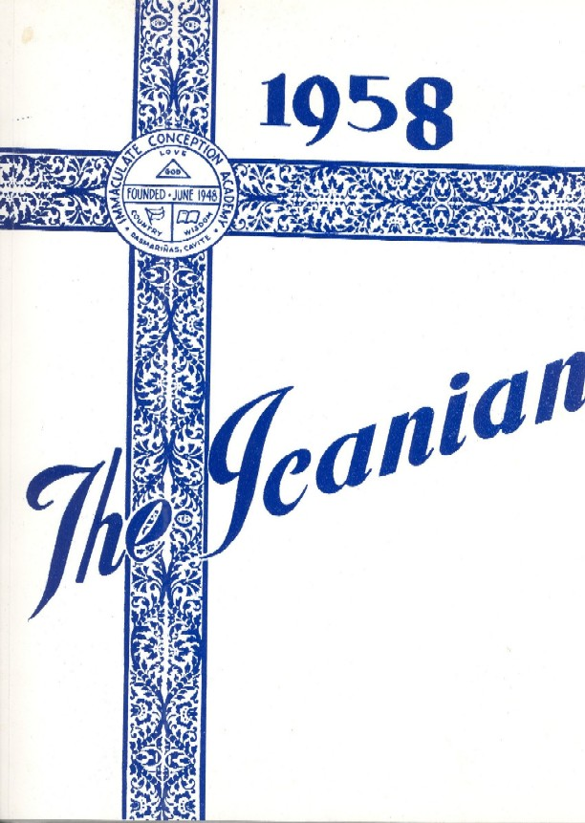
2006 DIRECTORY 
alcantara, abelardo  deceased |  | Wife - Liling
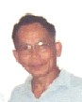 | 6237 Potomac St.  san diego, ca 92139 | 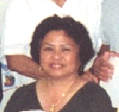
alcantara, ernesto | 6237 Potomac St.  san diego, ca 92139 | Wife-wilma
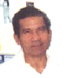 | 7926 Handel Way  san diego, ca 92126  Phone:  858-689-9094 | 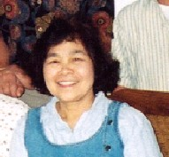
aledia, domingo | 7926 Handel Way  san diego, ca 92126  Phone:  858-689-9094 | tirona-aledia macaria
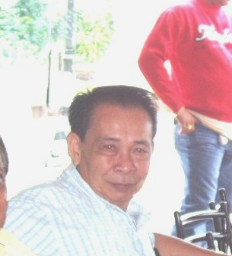 | 255 Pag-asa Subd  Anabu 1-b, Imus, Cavite philippines 4103  Phone:  046-471-5236  224-3401  0915-999-9749
austria, ernesto |  | Wife

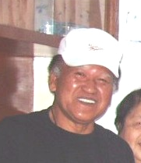 | 72 mangubat st  dasmarinas, cavite 4114  Cell: 0917-757-4771
baquer, Terry | 72 mangubat st  dasmarinas, cavite 4114  Cell: 0917-757-4771 | Wife
702 highland street
pasadena, ca 91104

Phone:
626-798-3521
E-mail:
rikcampos@yahoo.com
campos, ricardo |  | wife-nirva
cantada, edilberta | 10434 Bouquet Ave  adelanto, ca 92341  phone:  760–246-3243
56 malihan st
Dasmarinas, cavite 4114

phone: 046-416-0625
Cell: 0918-692-3190
cantimbuhan-octavo  Jovita |  | Husband-

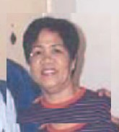 | 4837 Baldwin avenue  Temple city, CA 91780  PHONE:  626-579-2896 | 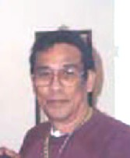
caranay-camet  elizabeth |  | husband-jim
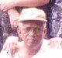 | Los BaÑos, Laguna
encabo, pio | Los BaÑos, Laguna | Wife
san agustin
dasmarinas, cavite 4114
PHONE:
046-416-2048
encabo, florencio | san agustin  dasmarinas, cavite 4114  PHONE:  046-416-2048 | Wife
 | 15 i. mangubat st  dasmarinas, cavite 4114  Cell:  0919-484-5610
ferrer,necitas

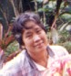 | 5730 S. kenwood ave.  Chicago, IL 60637  phone:  773-612-5281
geda, Remedios |  | Husband- deceased
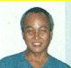 | ramirez st  dasmarinas, cavite 4114  91 Edward Werth dr.  rodeo, ca 9472  phone: 510-245-9192
gelle, feliciano |  | wife-norma
gonzaga-mendoza  erlinda |  | Husband- deceased
gonzales, hernando  deceased |  | wife -
hayag, benrubio |  | Wife
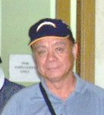 | 125-A san agustin  dasmarinas,cavite 4114  10775 Greenford Dr  San Digo, CA  Phone: 858-610-5081  Cell: 0918-465-4472 | 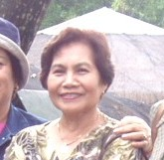
hembrador, florencio |  | wife - Del

hernandez, alfredo  deceased |  | wife - deceased
ilawan, Renato  deceased | aguinaldo hwy zone 1-a  dasmarinas, cavite 4114 | 
ilawan, Renato  deceased | aguinaldo hwy zone 1-a  dasmarinas, cavite 4114 | wife- nita
javier, leonardo
deceased
javier, leonardo  deceased |  | wife -
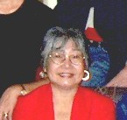 | 94 p. campos Ave  dasmarinas, cavite 4114  phone: 046-416-5198
legaspi-bayot, Lolita8 |  | Husband- deceased (nestor)
nave, francisco  deceased |  | wife -
 | san jose  dasmarinas, cavite 4114
ramos, apolinario | san jose  dasmarinas, cavite 4114

ricasata, herminia  deceased |  | Husband
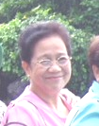 | 235 san jose  dasmarinas, cavite 4114  phone: 046-416-5203
sangria-Jason, Iluminada | 235 san jose  dasmarinas, cavite 4114  phone: 046-416-5203 | Husband- deceased
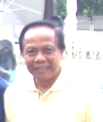 | 90-B castaneda st  up campus, diliman, QC  phone: 046-425-1842  Cell: 0917-417-1326  E-mail: jasantiaguel@yahoo.com
santiaguel, joaquin |  | wife -
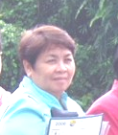 | 9 ramirez st  dasmarinas, cavite 4114  phone: 046-416-0515
santos de los-beltran, felicitas | 9 ramirez st  dasmarinas, cavite 4114  phone: 046-416-0515 | Husband- deceased (fely)

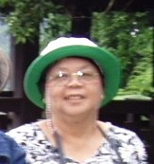 | Ed Bautista Street dasmarinas, cavite 4114  phone: 046-416-0515
sapida, marietta
15513 wicks blvd
san leandro, ca 94579

phone: 510-895-2439
046-416-0300(Dasma)
sinigayan-manimbao, emelita |  | Husband- deceased (benjamin)
Tirona-aledia, macaria | refer to domingo aledia | husband- domingo aledia
134 san jose
dasmarinas, cavite 4114

phone: 046-416-0035
Cell: 0927-751-2246
usis-camaÑag, victoria |  | Husband-  bing camaÑag

honorary members

Spouses are automatic honorary members, We welcome former classmates in high school & elementary school.

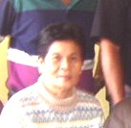 | aguinaldo hwy zone 1-a  dasmarinas, cavite 4114  phone: 046-416-0251  Cell: 0917-842-7128
Hapin-Calinisan, amalia |  | Husband- deceased
16 camerino ave
dasmarinas, cavite 4114

phone:046-416-1679
Cell: 0919-845-7765
veluz, roberto |  | wife -

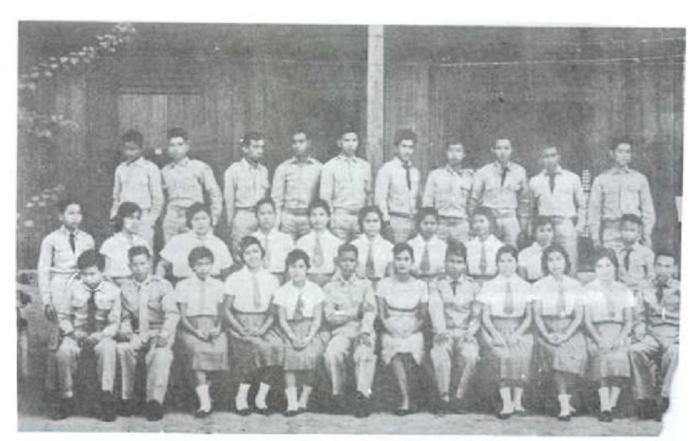

I. C. A. Class 1957-1958

